Ritendra Gour

ClickSpurr Pvt Ltd

20/09/2023

Subject: Proposal for Adding “Documentation Software Project” on CS-ERP Project.

Dear Sir,

I hope this message finds you well. I am writing to propose a comprehensive Documentation Software Project that aims to enhance our organization's efficiency, collaboration, and knowledge management. This project is designed to be completed within one month, and I believe it will bring significant benefits to our company.

**Background:** Our organization has experienced substantial growth in recent years, which has led to an exponential increase in the volume of digital documents and files. This rapid expansion has made it increasingly challenging to manage, locate, and secure critical documents efficiently. As a result, we are facing several issues, including:

1.       Difficulty in accessing and retrieving important documents in a timely manner.

2.       Concerns regarding data security and compliance, as our current system lacks robust security measures.

3.       Inefficient document collaboration and version control, leading to errors and duplications.

4.       Limited visibility into document usage and access history.

**Objective:** The primary goal of this project is to design, develop, and implement a comprehensive documentation storage software system that addresses these challenges.

**Project Timeline :**

We propose a project timeline of **26 Sep to 21 Oct 2023 (**one month**)**, with the following milestones:

•  Week 1 (**26 Sep - 30 Sep**): Requirement gathering and project planning & Setup.

•  Week 2,3 (**03 Oct – 14 Oct**): Software design and architecture development.

• Week 4 (**17 Sep – 21 Oct**): Software development and testing User training, deployment, and final testing.

**Benefits:** Upon successful completion, the Documentation Storage Software Project will bring several benefits to our organization, including:

1.       Enhanced productivity through streamlined document management.

2.       Improved data security and compliance adherence.

3.       Increased collaboration and communication efficiency.

4.       Enhanced decision-making with data-driven insights.

5.       Cost savings through reduced time spent searching for documents.

**Database Schema :** We will create two new tables ‘documentation & doc_category’. Use the ‘User’ table (old table) because it is the main table and the Users table contains all the user data.

**Documentation Table :** We will provide five column in UI ‘doc_category , title, file_path , description, privacy’ and other field in automation .

* **doc_category** (ex. Password, URL etc)
* **title**
* **description**
* **file_path** (ex. Image, zip etc)
* **privacy** (ex. Public , Private)

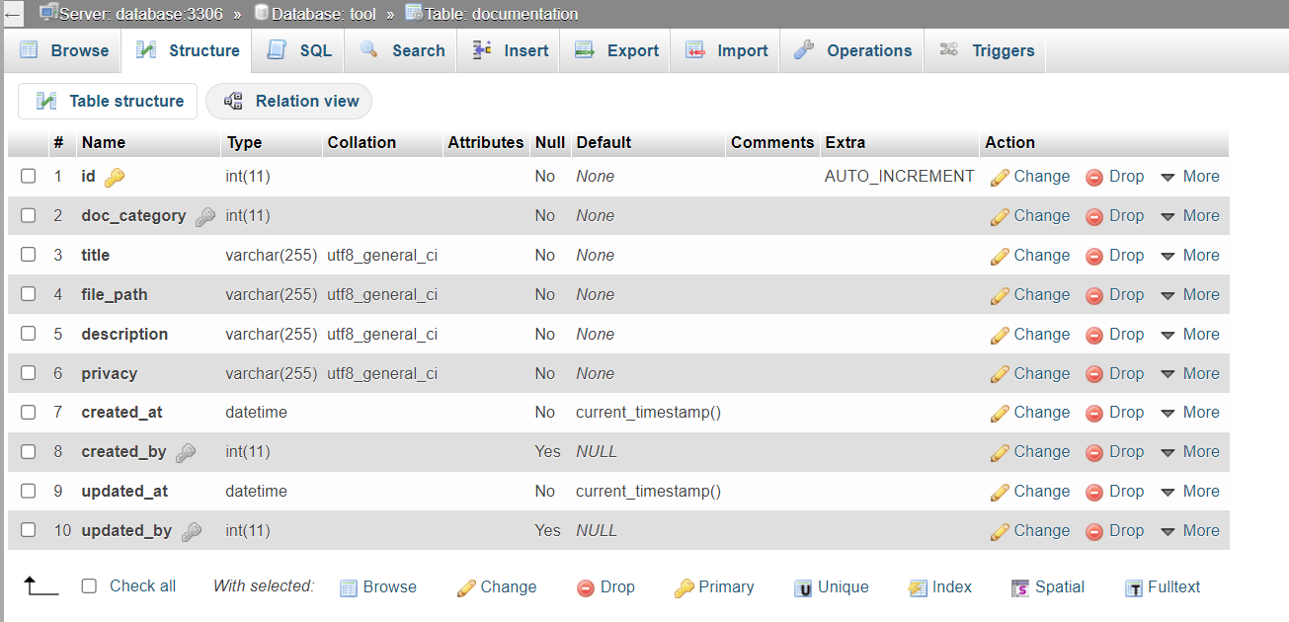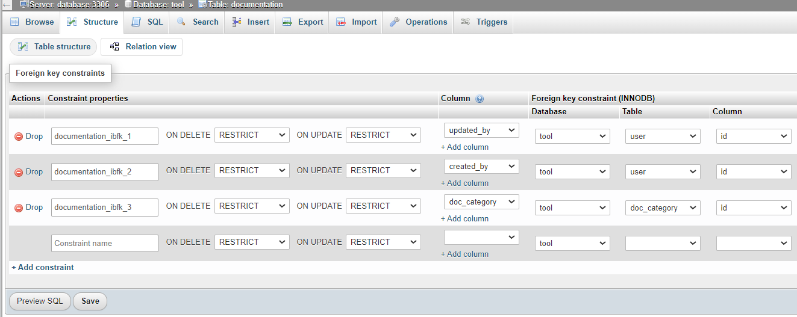

**Doc_** **category Table :** We will provide only one column in UI ‘name’ and other field in automation

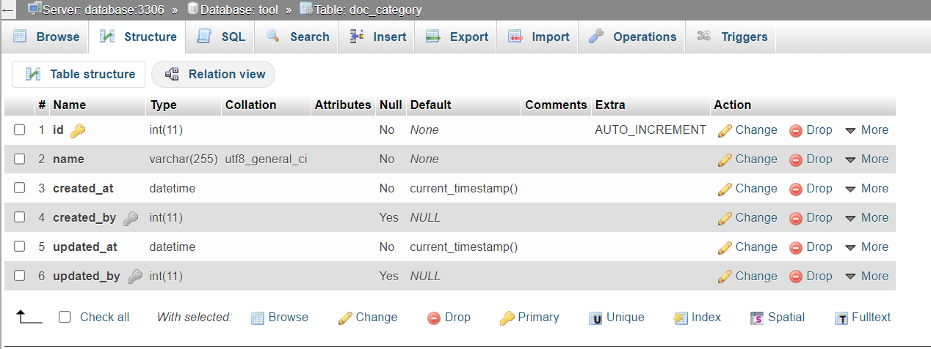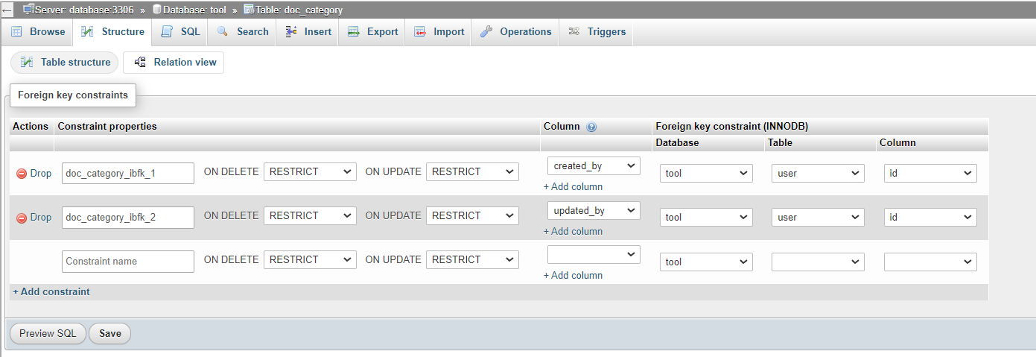

**User Table :**

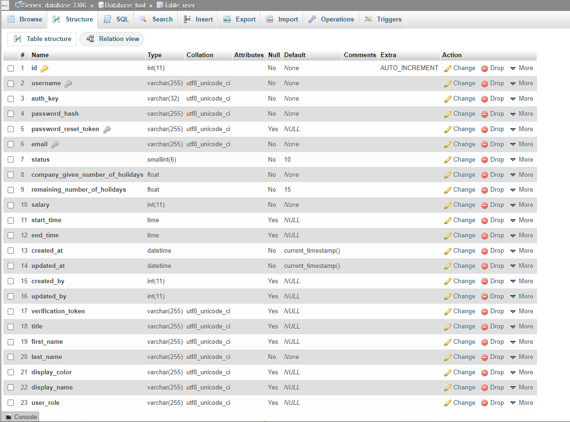

**Conclusion:** I believe that this project is essential for our company's continued growth and success. A well-organized and secure document management system will significantly improve our operations and allow us to remain competitive in our industry.

I kindly request your approval and support for this project, including the necessary resources and budget allocation. I am confident that with the right resources and a dedicated team, we can complete this project successfully within the proposed timeline.

I look forward to discussing this proposal further and addressing any questions or concerns you may have. Thank you for considering this important initiative.

Sincerely,

Ritendra Gour